Sex Offender Utility

**Town of Southampton** - Land Manager

This utility is to assist The Town of Southampton Police Department manage their level 1 sex offender information. It shows the locations of the Level 2 and Level 3 offenders living in our area. The locations for the Level 2 and Level 3 offenders are their residences.

Open the Panel

1. Select Police Info to view the Sex Offender Panel

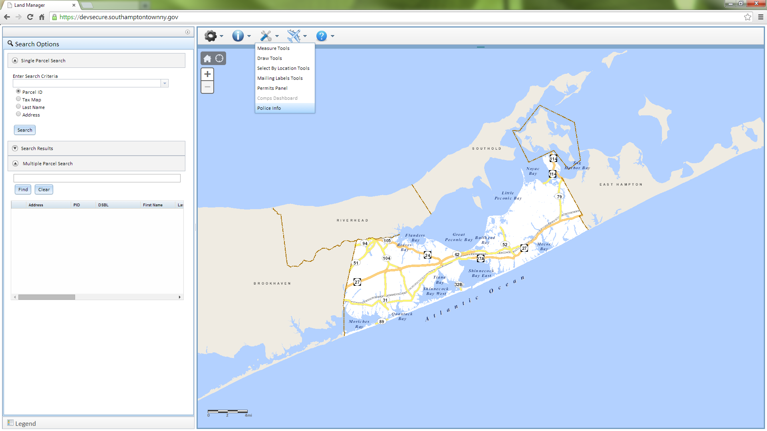 *This will also close the panel if it is open*

1. Enter the Username and Password (disregard the domain) when prompted
   1. username: p
   2. password: p <-- case sensitive
2. The Sex Offenders Panel will popup. Initially there will be two buttons and a list of all the unmapped Level 2 and Level 3 offenders that we have in our database.

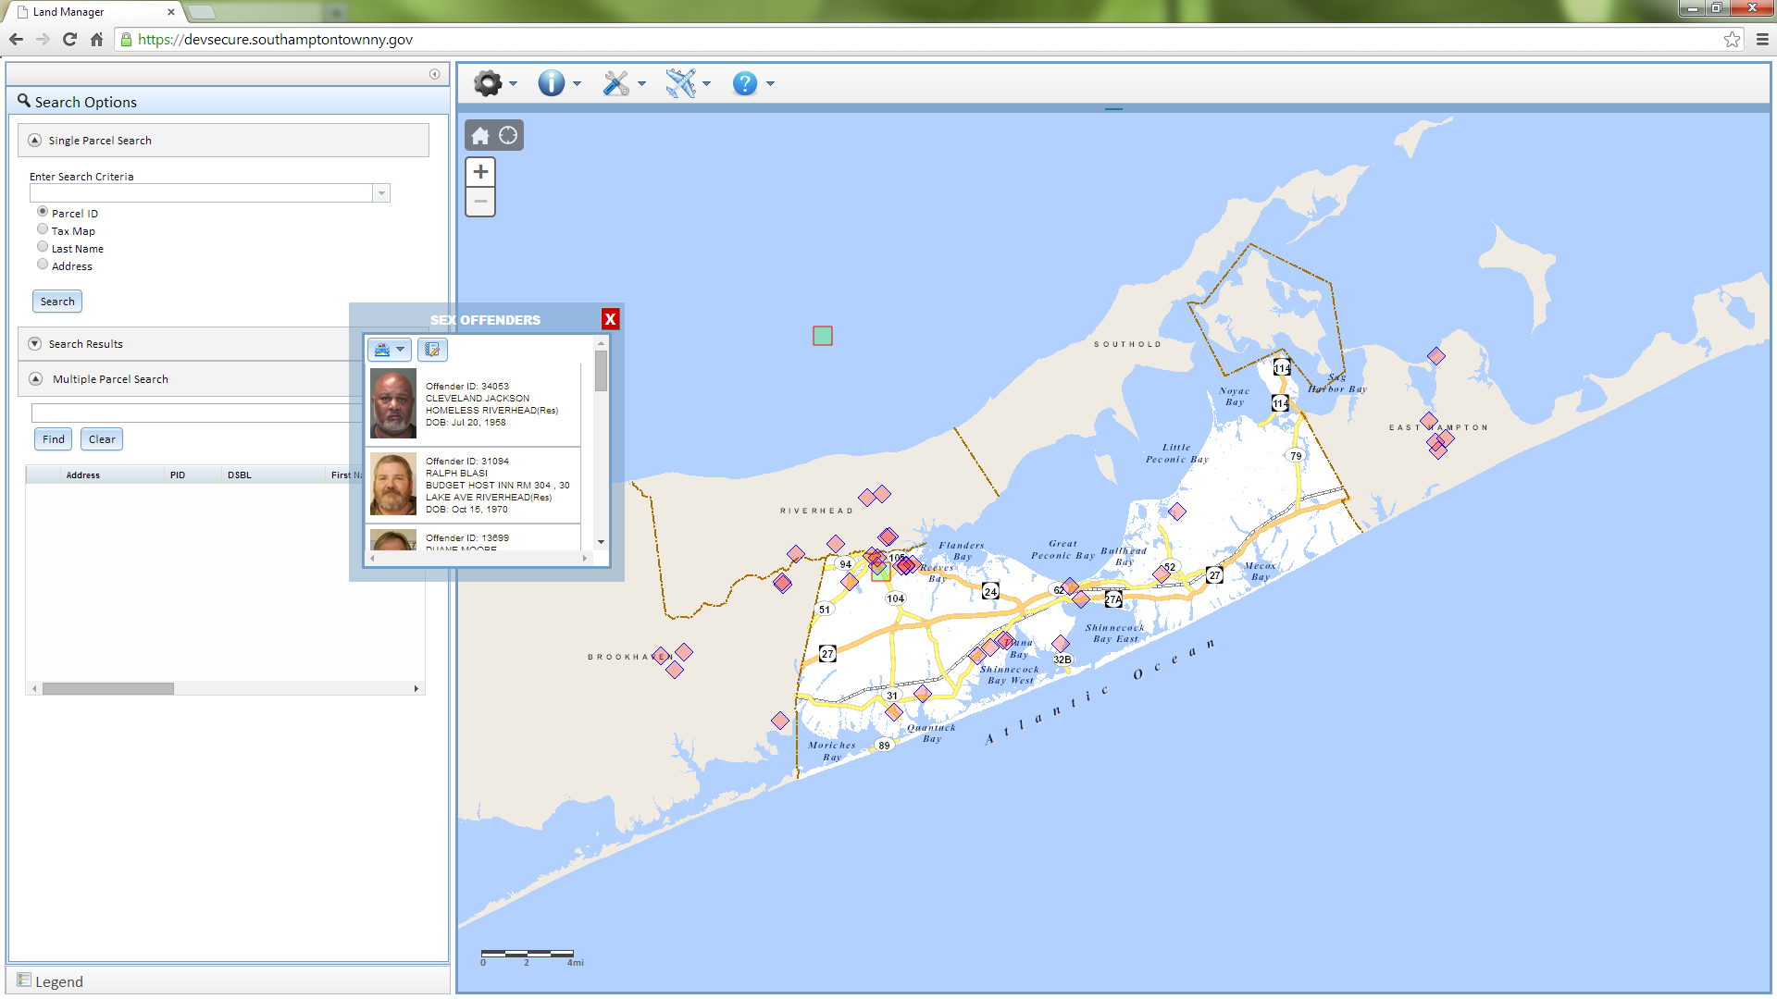

1. Layers Dropdown Button C:\inetpub\wwwroot\LandManagerJS\images\layers.png
   1. Toggle Level 1 Offender Layer On / Off
   2. Toggle Level 2 and Level 3 Layer On / Off
2. Editor button C:\inetpub\wwwroot\LandManagerJS\images\report-edit-icon.png
   1. Enable / Disable the editor options
3. Close Button
   1. Will turn off both offender layers, disable editor as well as close the panel
   2. The user needs to log in each time that the panel is open

Edit Options

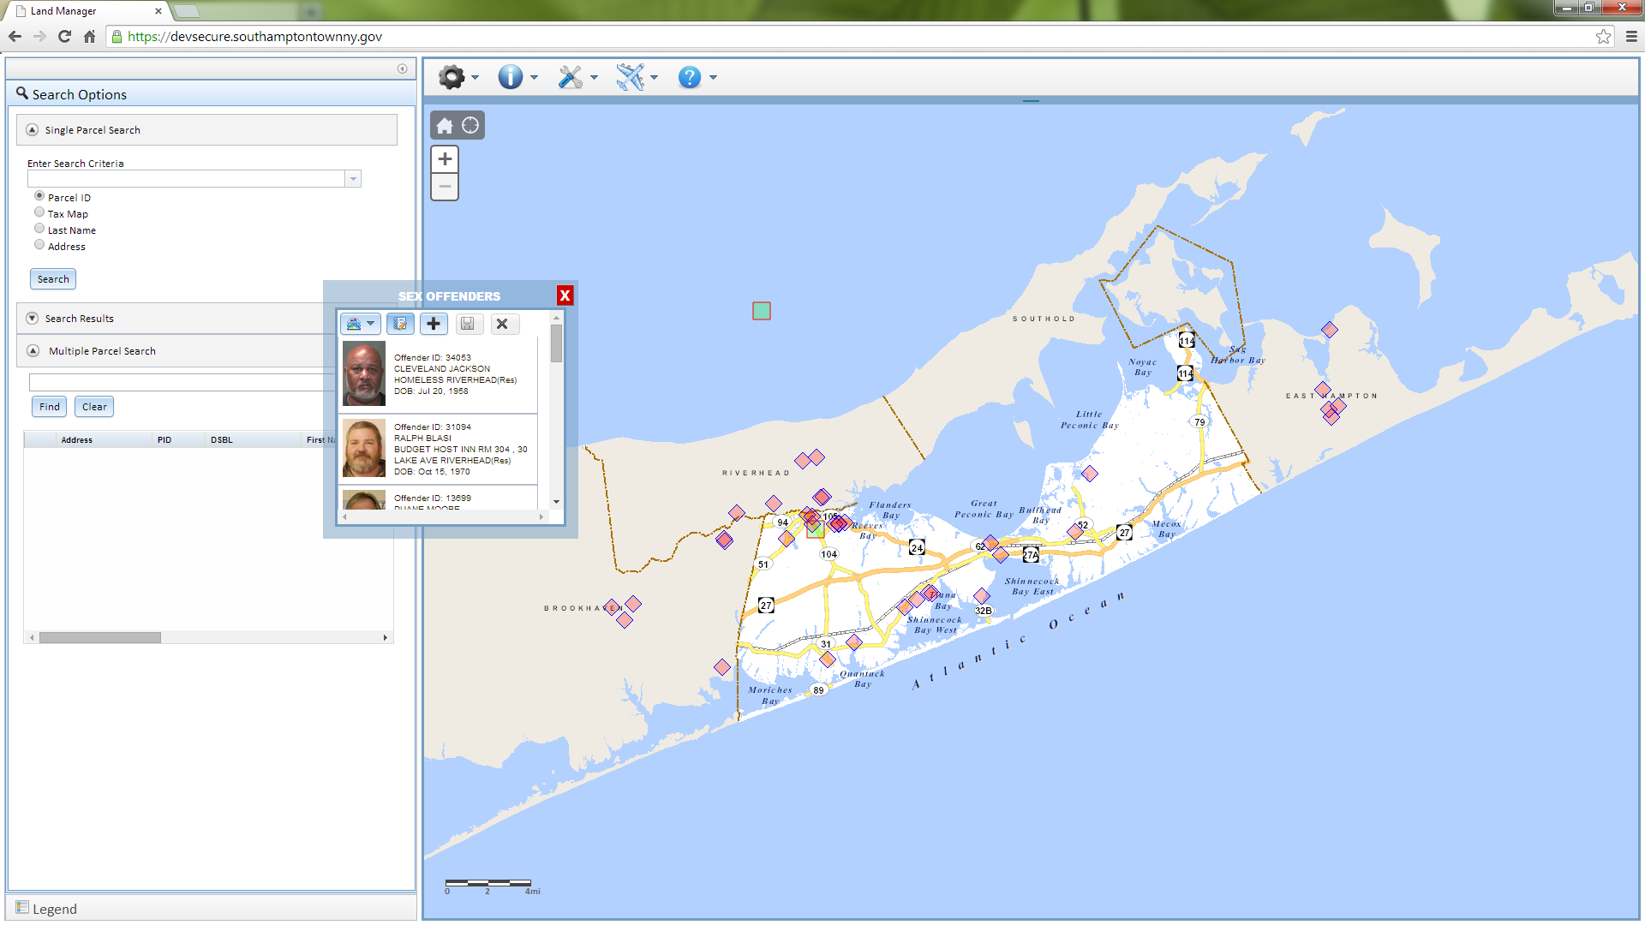

1. Add C:\inetpub\wwwroot\LandManagerJS\images\Add-icon.png
   1. Allows user to add Level 1 offenders to the map (level 2 and level 3 information cannot be added or changed through this utility).
   2. Click the button and then click the location on the map.
   3. Click on the point to edit Information Name and Address information

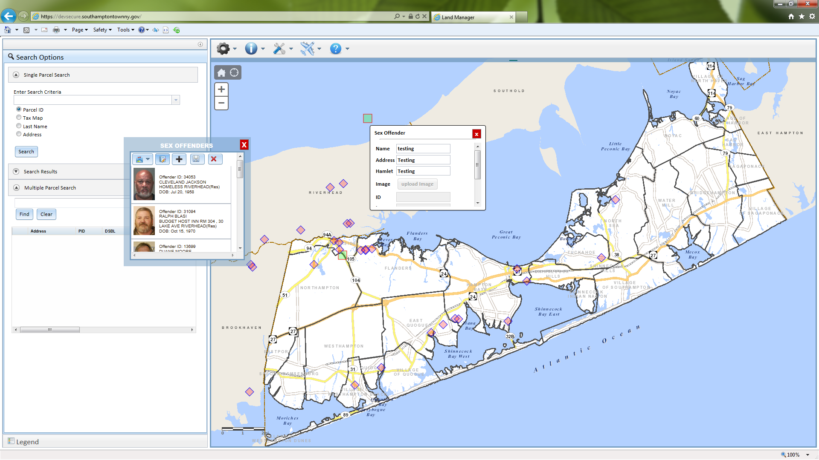

*This is only available while the editor is enabled*

* 1. After a level 1 offender has been saved, photos can be uploaded

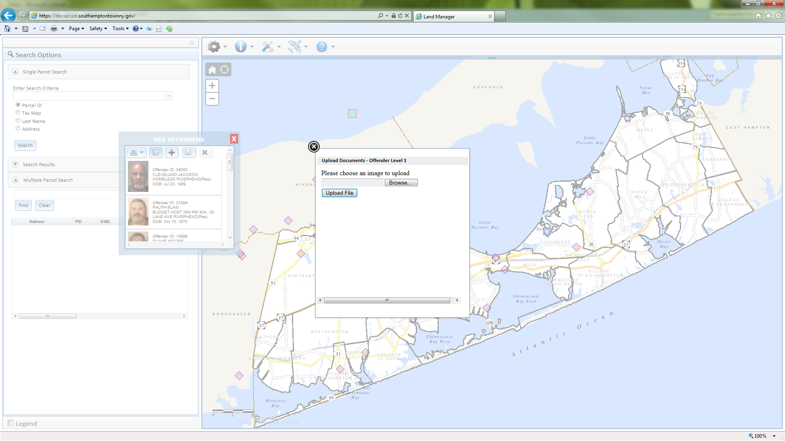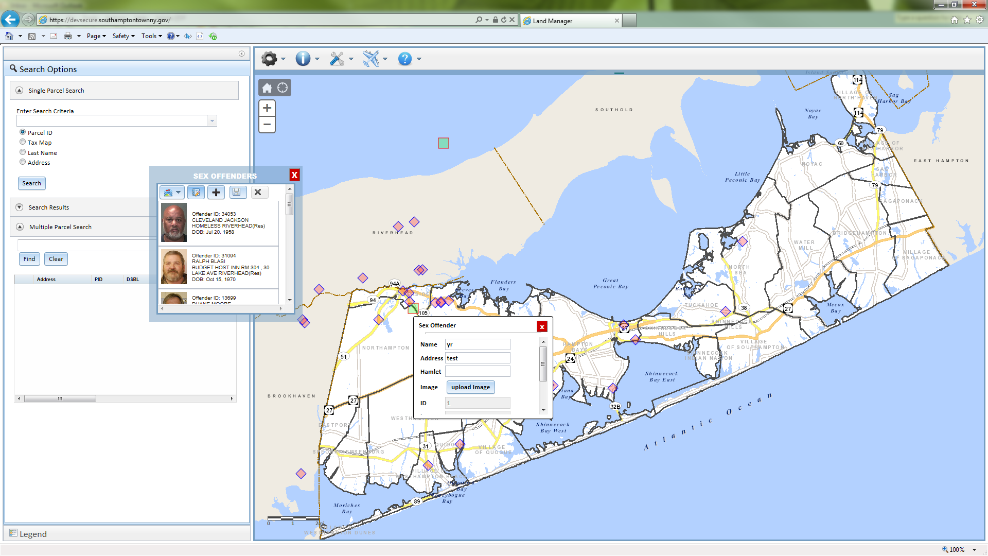

1. Save
   1. This button will be disabled until the user has made a change or added a point
2. Delete
   1. Will be disabled until a level 1 offender is clicked

If the user makes an edit then closes the panel without saving the information those changes will remain along with the Internet browsing session if the user wants to refer back to those changes.